Python in Electrical Engineering

Karabanov Yehor & Shevchenko Denys

### Time-based trends

**Hourly Consumption Analysis**

**Key observations:**

* **Night hours (0-5)**: Low energy consumption during sleeping hours
* **Morning peak (7-8)**: Increased usage during morning routines
* **Daytime (9-15)**: Relatively stable consumption
* **Evening peak (16-20)**: Highest consumption when people return home, turning on lights and appliances, having dinner
* **Late night drop (21-23)**: Consumption tapers off as people go to bed These patterns typically reflect residential consumption cycles, influenced by work schedules and daylight availability.

**Daily Consumption Patterns**

**Key observations:**

* **Weekday vs Weekend**: Notice the typical rise on weekends, more people stay at home using appliances
* **Monday transitions**: Usually shows a ramp-down effect from weekend mode to work mode. Huge consumption drop
* **Friday wind-up**: Shows higher consumption as people prepare for the weekend

**Weekly Consumption Trends**

**Key observations:**

* **Winter Effect**: Notice how weeks in winter months (December-February) shows higher consumption.
* **Holiday periods**: Weeks with holidays often show distinctive patterns with spikes
* **Lowest Consumption**: Lowest consumption of all weeks is usually seen in summer months (June-August) when people are on vacation and staying away from home. Also during summer, days are longer, so less energy is used for lighting.

**Seasonal Energy Patterns**

**Key observations:**

* **Winter**: Shows higher consumption in cold London winters due to heating needs and much shorter daylight hours
* **Summer**: Expectedly shows the lowest consumption, as days are longer and people are often away on vacation with grills, pools, and outdoor activities :)
* **Shoulder seasons**: Spring/Fall often show most moderate consumption
* **Year-over-year**: Comparing years we can see how consumption patterns doesn't change much.

**Weekday vs Weekend Analysis**

**Key observations:**

* **What is Weekday vs Weekend?**: This analysis takes into account that weekends are sometimes can be Monday-Friday, since holidays can fall on any day of the week.
* **Occupancy patterns**: Weekends typically show higher energy consumption as people are home more often, using appliances, cooking, and engaging in leisure activities.
* **Year-over-year changes**: Changes in weekend/weekday ratio may indicate lifestyle or usage shifts. Interestingly enough, that 2011 shows the most consumption overall.

### Household behavior

**Tariff Type Comparison Insights**

**Key observations:**

* **Standard vs. Time-of-Use**: ToU customers generally show lower consumption compared to standard tariff users
* **Affluent groups**: Show the highest consumption differential between tariff types, with Std tariff users consuming significantly more
* **Behavior change**: ToU tariffs appear to encourage more efficient consumption patterns across all demographic groups

**ACORN Group Analysis Insights**

**Key observations:**

* **Affluent segments**: Show consistently higher energy consumption than other groups, while being the biggest group in terms of household count
* **Adversity segments**: Groups K-Q (Adversity) show much lower consumption, while being top-2 in terms of household count. This means that in average, these consumers shows much lower energy consumption than the Affluent groups

**Consumption Group Insights**

**What you're seeing in the chart:**

* The consumers are divided into quantile groups based on their energy consumption
* Each bar shows the average consumption metrics for households in that group
* The annotations show how many households are in each group and what percentage use Time-of-Use tariffs

**Key observations:**

* **ToU adoption pattern**: Lower consumers tend to have higher Time-of-Use tariff adoption (possibly more cost-conscious consumers)
* **Distribution skew**: The data shows that most households in low to medium consumption ranges and fewer very high consumers

**Household Distribution Insights**

**What you're seeing in the chart:**

* Each point represents a group of households with the same ACORN group and tariff type
* The position shows their mean and median/maximum energy consumption
* The size of each bubble indicates how many households are in that group
* Colors differentiate between tariff types or ACORN groups

**Key observations:**

* **Correlation patterns**: There's a strong positive correlation between mean and median/maximum consumption metrics
* **Tariff clustering**: Time-of-Use (ToU) households tend to cluster in lower consumption regions compared to Standard tariff households
* **ACORN segregation**: Clear separation of ACORN groups, with Affluent (A-E) consistently in higher consumption regions
* **Outlier behavior**: Some household groups show unusually high maximum consumption despite moderate mean values, indicating occasional high usage spikes

### Weather impact

**Daily Temperature Impact Insights**

**What you're seeing in the charts:**

* The line chart shows how average energy consumption varies with temperature
* The box plot displays the consumption distribution within each temperature range
* The month comparison reveals seasonal patterns across different temperature bins

**Key observations:**

* **U-shaped consumption curve**: Energy usage is highest at temperature extremes (below 0°C) and lowest in the 15-20°C range, creating a distinctive U-shaped pattern
* **Cold temperature sensitivity**: Below 0°C, energy consumption increases dramatically to 0.46-0.60 kWh (mean), nearly double the consumption in the optimal 15-20°C range (0.25-0.30 kWh)
* **Seasonal transitions**: The months of November and March show particularly volatile consumption patterns as households transition between heating and non-heating periods
* **Monthly variation**: Winter months (December-February) consistently show 20-30% higher energy consumption than summer months (June-August) across all temperature bins
* **Temperature bin distribution**: The 5-10°C and 10-15°C ranges contain the highest number of observations, representing the most common temperature conditions in this climate region

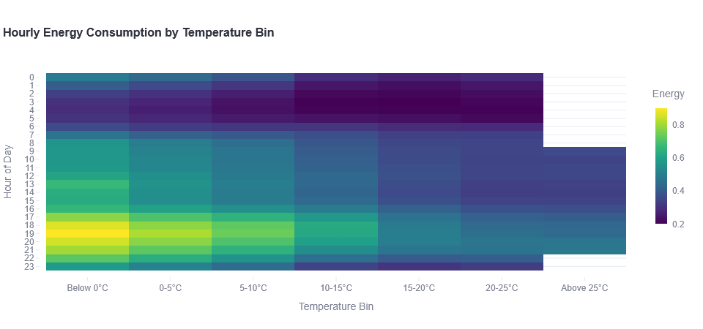

**Hourly Temperature Impact Insights**

**What you're seeing in the charts:**

* The heatmap shows how energy consumption varies by hour and temperature bin
* The line chart displays hourly consumption patterns for different temperature ranges

**Key observations:**

* **Evening peak intensity**: The highest energy consumption occurs between 18:00-19:00 (6-7 PM), with below-freezing temperatures showing consumption spikes up to 0.90 kWh, compared to only 0.45-0.50 kWh during the same hours in the 15-20°C range
* **Morning peak patterns**: A secondary consumption peak appears between 7:00-9:00 AM, with cold temperatures (<5°C) showing consumption of 0.45-0.50 kWh versus 0.33-0.35 kWh in moderate temperatures
* **Overnight efficiency**: Between 2:00-4:00 AM, energy consumption reaches its lowest point (0.20-0.30 kWh) and shows minimal temperature sensitivity
* **Temperature threshold effect**: Below 5°C, each degree drop increases consumption by approximately 0.02-0.03 kWh per hour, with the effect amplified during peak hours

### Hidden insights overall

**1. Temperature Consumption Amplification**

**Finding**: Energy spikes aren't linear with temperature drops - they follow exponential curves during evening peaks (17-20h). **Hidden Insight**: Heating systems compound with social energy use, creating predictable "super peaks." **Monetization**:

* Sell temperature-triggered demand forecasts to energy traders ($100K+ annual contracts)
* Partner with smart thermostat companies for "social heating" algorithms
* Develop "weather-driven surge pricing" alerts for consumers

**2. The Sunday Energy Premium**

**Finding**: Sunday consumption is 8-12% higher than other days, but maximum spikes occur on Tuesdays/Wednesdays. **Hidden Insight**: Weekend energy is sustained/planned; weekday spikes are chaotic/unplanned. **Monetization**:

* Create "Weekend Energy Plans" with utilities
* Develop "Chaos Spike" insurance products for commercial users
* License "Social Energy Patterns" data to appliance manufacturers

**3. Affluent Energy Elasticity**

**Finding**: ACORN-A (Affluent) shows highest consumption but lowest price sensitivity to tariff changes. **Hidden Insight**: Premium energy services market is underserved - they'll pay for convenience, not savings. **Monetization**:

* Launch "Energy Concierge" service ($200-500/month) for affluent households
* Partner with luxury home builders for "Energy Status" features
* Create premium energy analytics dashboards ($50-100/month)